Policy on Payment Claims for Professional Masters of Education (PME) part-time personnel

Approved by the Head of School on 11th July 2022

If you are a new member of staff, or a continuing member of staff who is now outside of their initial hourly setup dates, you will need to create an hourly setup form online prior to it being jointly processed by the School of Education and UCD HR. Information on how to create an hourly setup form is available in this link.

If you are a continuing member of staff, you will need to input and submit your Timesheets Online via: UCD Connect/Employee Self Service/My Hourly Timesheets Self Service/Create New Timesheet, and completing the relevant Hours Completed or Items Completed sections and selecting your nominated approvers before submitting the timesheet for payment, link here.

If you are having technical issues around timesheet submission, please contact hrhelpdesk@ucd.ie detailing the issue, and send them through a screenshot if possible.

More Information around this process can be found at this link.

- Payment rates
Payment rates are set up by UCD Human Resources and can be accessed online.

Position Description | 2010 Rates
Professional Practice Tutor (School of Education & Lifelong Learning only) | € 41.00
Professional Placement Supervision per visit (School of Education & Lifelong Learning) | € 74.88
Occasional Lecturer | € 85.32

- Other rates
2.1 Professional Development Meetings
The school policy is that supervisors and tutors may claim for attending the professional development meetings for staff by way of submitting one supervision visit online in ESS for two professional development meetings attended.

Methodology lecturers may claim for attending the professional development meetings by way of submitting one hour at an occasional lecturer rate for two professional development meetings attended.

The hourly rate of pay to supervisors covers meetings and phone calls with students including pre-arranged meetings. Hence, no additional payment is made in respect of phone calls, or additional interaction or correspondence with students.
Mileage may not be claimed for informal meetings with students as this cost is included in the hourly rate of pay.
2.2 Supervisor Introductory meetings
These meetings should take place online in supervisor groups and one supervision meeting may be claimed for this meeting. If supervisor groups are over 16 then two group meetings may be arranged.

2.3 Tutor Administration
Given the additional pastoral role and responsibility of the tutor it has been agreed that tutors may claim additional hours as follows:
- PME 1 - 8 additional hours at the tutor rate over the course of the year
- PME 2 - 4 additional hours at the tutor rate over the course of the year

2.4 Mock Interviews

Mock interviews are paid at the tutor rate of 1 hour per student at the tutor rate.

- Internal Examiner Claims
Correction of PME assessments can be claimed through ESS in the ‘Items’ section of the timesheet.
As per the University Internal Examiner Rates of pay;

Correction of PME assessments are paid at the correction rate of a 5,000 word essay (€11.54).

With the exception of the PME portfolio for which the correction is paid at the rate of a 7,500 word essay (€15.58).

UCD systems and internal examiner pay rate procedures are not set up for multiple assessors of single assessments.

4. Field trips
Field trips should be organised only with prior consultation with the course directors.

A flat rate of €400 per field trip will be paid to the methodology lecturer and hourly tutor rate will be paid to the second staff member attending.

The bus company will be booked by the School Office.

5. PME 2 Dissertation Supervision
PME 2 Dissertation supervisors can claim a flat rate of €200 per student supervised.

This work can be claimed by submitting a completed Ad Hoc payment form to education@ucd.ie. The form will be sent in advance.

6. Mileage
All mileage expenses forms (only digital versions accepted) can only be claimed by submission to the UCD School of Education office, to education@ucd.ie.

Please complete and submit the Expense Form (excel version, screenshot below).
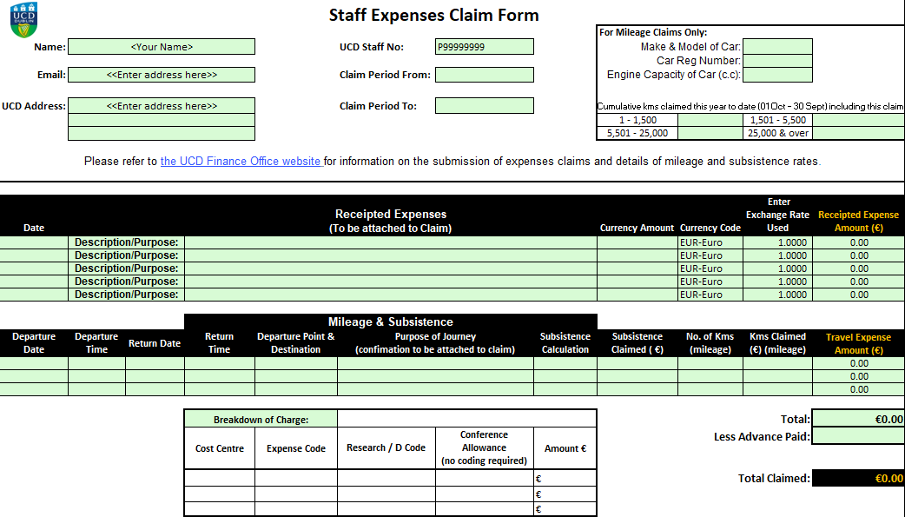

IMPORTANT: All sections at the top of the Expense Form must be completed. The Bursar’s Office will NOT facilitate payment if total kilometres and overall total in euros is not indicated. Please do not edit this document, no more lines can be added.

If you will require additional lines under the “Mileage & Subsistence” section please use the Additional Journeys Detailed Mileage Form (excel version, screenshot below) and list the total in the Expense Form.
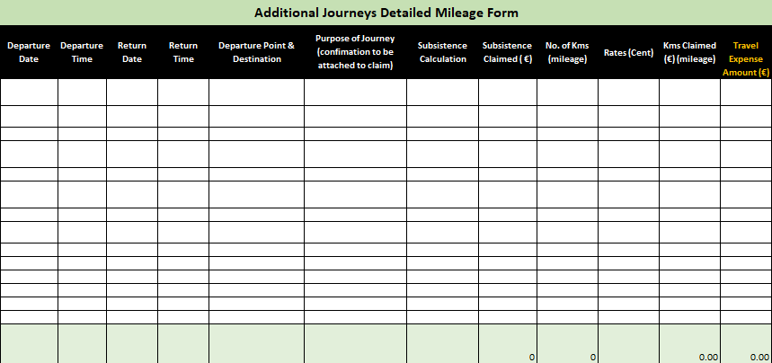

Supervisors and Tutors of the Professional Masters of Education (PME) are also required to submit the Mileage Details Form – Supervision of Teaching Practice (word document, please see below).
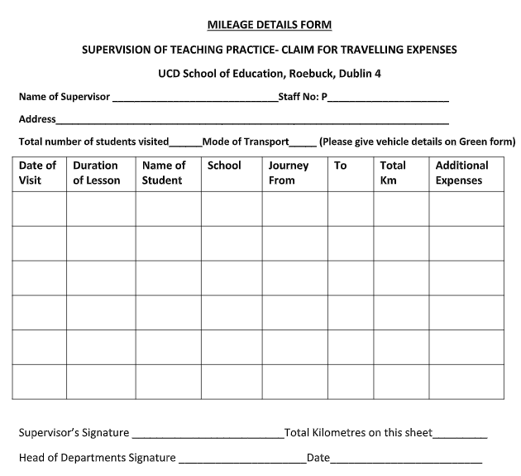
IMPORTANT: UCD travel policy states that mileage claimed should be from UCD to the destination. You cannot claim for mileage from your home to the destination unless the distance from your home to the destination is shorter.

IMPORTANT: UCD Bursar’s Office will NOT process forms not fully completed and signed. Please ensure that you have fully filled out your personal details at the top of the form and the highlighted items. To convert the total Kms into Euro, please use the Kilometre Rates for Cars below.
Please refer to Kilometre Rates for Cars below to convert total kilometres into Euros.
For example: total of 53 km (engine capacity 2191cc) - 53 multiplied by 0.5907 = €31.30

For example, Total Kms of 153 x 0.5907 (Engine Capacity 1,501cc and over) = € 90.37 to be claimed

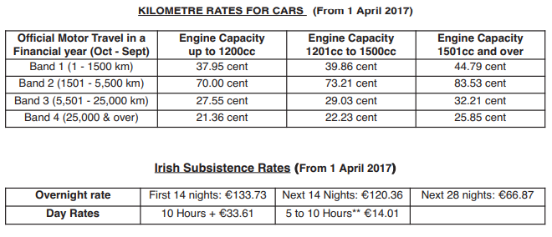

Useful University Resources and Information
Guide to UCD Modular Grades
Internal Examiner Payment Rates

All forms (only digital versions accepted) must be submitted to education@ucd.ie.

For further information on Mileage Guidelines & Rates please visit our website.

